
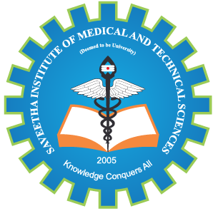
SIMATS ENGINEERING

Saveetha Institute of Medical and Technical Sciences
Chennai- 602105

Student name :KIRUTHIKA.B Reg. No.:192511232
Course Code: CSA0974 Slot: C
Course Name: JAVA PROGRAMMING
Course Faculty: Dr.R MOHAN & Dr.MEGANATHAN
Project Title: AI-Powered Resume Screening and Candidate Ranking System
Module Photographs:
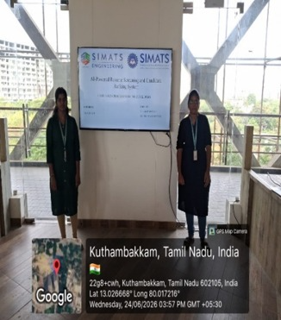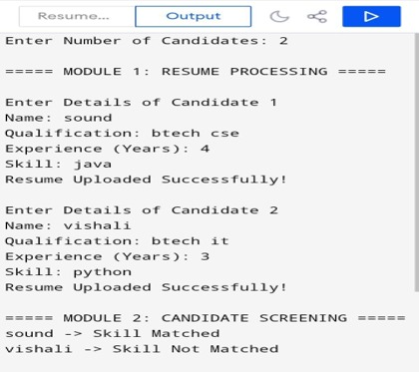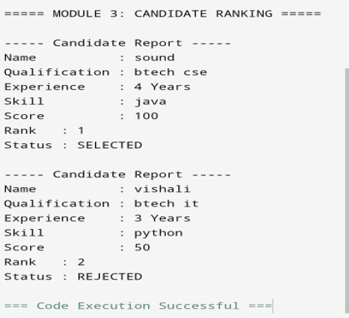
Project Description:
The AI-Powered Resume Screening and Candidate Ranking System is a smart recruitment solution that uses Artificial Intelligence (AI), Machine Learning (ML), and Natural Language Processing (NLP) to automate the hiring process. The system analyzes resumes, extracts important information such as skills, education, experience, and certifications, and compares it with the job requirements provided by recruiters. Based on the matching score, candidates are ranked according to their suitability for the job.
This helps organizations reduce manual screening efforts, save time, improve hiring accuracy, and efficiently manage large numbers of job applications while supporting fair and data-driven recruitment decisions. It analyzes candidate resumes, compares their skills, qualifications, experience, and keywords with the job requirements, and ranks candidates based on their suitability. This reduces the time and effort required for manual screening while improving the accuracy and fairness of candidate selection. The system enables recruiters to quickly identify the most qualified applicants, making the hiring process faster, more efficient, and data-driven. It can also generate reports and rankings to assist HR professionals in making informed hiring decisions.

Student Signature Guide Signature

